Code Crawler
Technical Metrics Report

Version 0.4

Revision History
Date | Version | Description | Author
4/28/05 | 0.1 | Initial skeleton and dependency graphs | Kinis Meyer
4/30/05 | 0.2 | Modified skeleton, and added data | Omar Ghaffar
5/01/05 | 0.3 | Added explanation after each metric | Omar Ghaffar
5/02/05 | 0.4 | Reviewed document | Nikolay Kojuharov
Table of Contents
1. Introduction 4
2. Number of Lines of Code 5
3. Mean Depth of Inheritance Tree 6
4. Number of Children 7
5. Instability 8
6. Lack of Cohesion of Methods 9
7. Abstractness 10
8. Weighted Methods per Class 11
9. Dependency Graphs 12
9.1 Util Package 12
9.2 CodeBank CVS Portion 13
9.3 CodeBank without CVS 13
9.4 CodeCrawler Indexing 14
9.5 Formatting 15
9.6 Search 15

Technical Metrics Report

Introduction
The purpose of this technical metrics report is to summarize the metrics collected through incremental stages of CodeCrawler’s development, and to provide the dependency graphs of version 1.0’s implementation to give a high-level view of the source code.

Our team is using Metrics 1.3.5 from SourceForge.net found at: http://metrics.sourceforge.net/ for our numbers. The inspiration for the metric descriptions came from “Object-Oriented Metrics, measures of Complexity” by Brian Henderson-Sellers, and from Robert Martin’s book “OO Design Quality Metrics, An Analysis of Dependencies”.

Each metric was calculated and recorded every bi-weekly between February 1 and April 15. The data from the most useful metrics was then graphed to see trends, giving a better idea of how the project was progressing.

Number of Lines of Code

 | February 1 | February 15 | March 1 | March 15 | April 1 | April 15
CodeAnalysis | 45 | 13 | 45 | 67 | 81 | 81
Codebank | 168 | 27 | 240 | 240 | 238 | 306
Formatting | 15 | 18 | 15 | 15 | 94 | 94
Indexing | 154 | 151 | 194 | 240 | 259 | 284
Search | 45 | 25 | 44 | 44 | 20 | 27
UI/action | 145 | 145 | 162 | 162 | 150 | 162
Util | 129 | 129 | 372 | 392 | 485 | 295

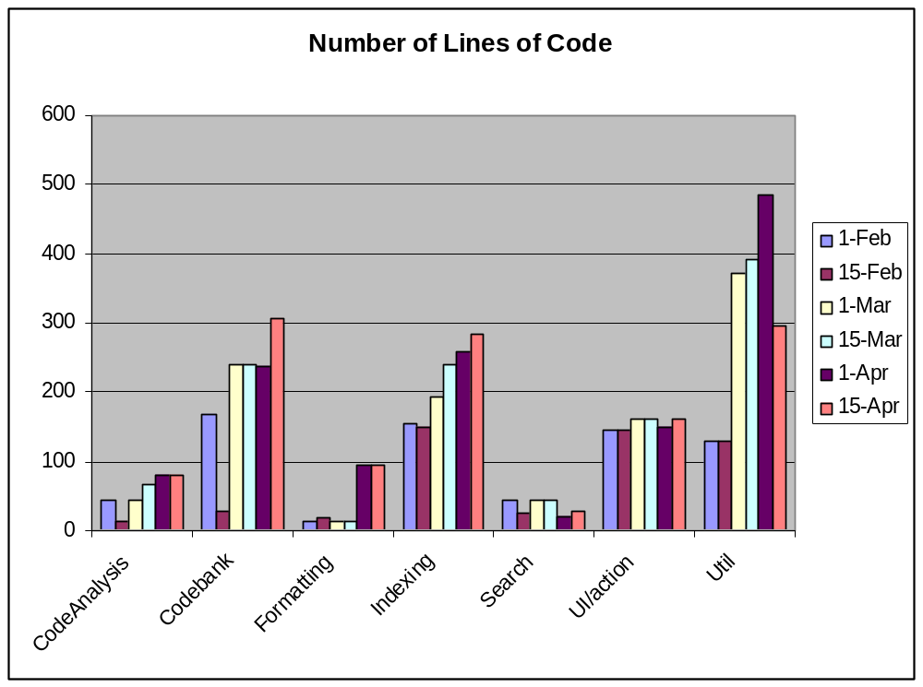

This metric is interesting in that it helps see when modules were worked on, and also indicates some times when modules have been refactored. It, however, does not reflect the quality of the code being developed and can only be used as an activity indicator.

Mean Depth of Inheritance Tree

 | February 1 | February 15 | March 1 | March 15 | April 1 | April 15
CodeAnalysis | 3 | 3 | 1 | 3 | 1 | 1
Codebank | 1.727 | 3 | 3 | 3 | 1.778 | 2.4
Formatting | 3 | 1 | 3 | 1 | 2.25 | 2.25
Indexing | 3 | 2.2 | 2.143 | 2.5 | 2.25 | 2.111
Search | 3 | 3 | 1 | 1 | 1 | 1
UI/action | 3.714 | 3.714 | 3.833 | 3.833 | 3.875 | 3.875
Util | 1 | 1 | 1.143 | 1.143 | 1.143 | 1.143

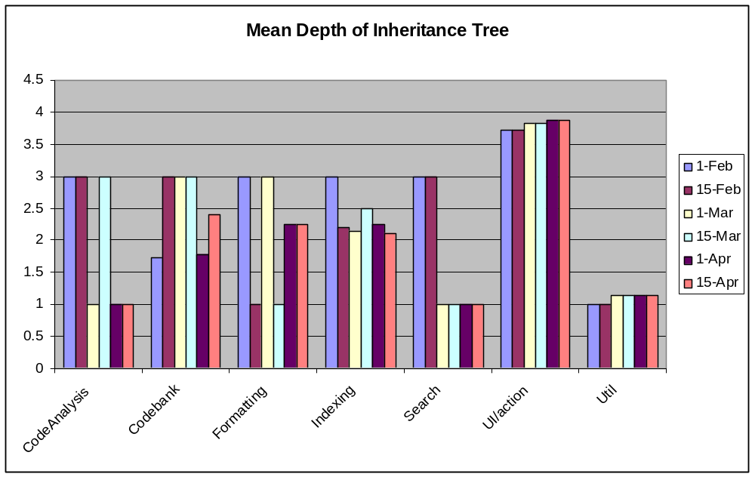

The Mean Depth of Inheritance Tree calculates the length of each node in the object graph to the root of the tree. The deeper a class is in the hierarchy, the grater the number of methods it is likely to inherit, making it more complex to predict its behaviour. Deep inheritance trees also indicate a greater potential for reuse of inherited methods. This metric indicates when packages were refactored, and also shows that some packages had their class hierarchies flattened out, while others had an increase in reuse of methods through inheritance.

Number of Children

 | February 1 | February 15 | March 1 | March 15 | April 1 | April 15
CodeAnalysis | 0 | 0 | 0 | 0 | 0 | 0
Codebank | 6 | 6 | 6 | 6 | 6 | 8
Formatting | 0 | 0 | 0 | 0 | 0 | 0
Indexing | 0 | 0 | 0 | 0 | 1 | 1
Search | 0 | 0 | 0 | 0 | 0 | 0
UI/action | 4 | 4 | 4 | 4 | 6 | 6
Util | 0 | 0 | 4 | 4 | 4 | 4

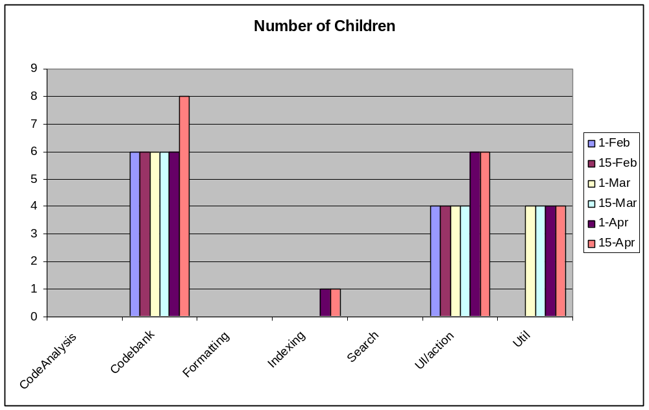

The number of children measures how many sub-classes are going to inherit the methods of the parent class. The greater the number of children, the greater the chances of reuse are. However, a large number of children may also indicate to us the likelihood of improper abstraction of the parent class, or even a misuse of subclassing.

Three packages had classes with no sub-classes. These packages had classes which were very specialized, and did not require much reuse across their classes. The other four did not see a significant change in their number of children. More scrutiny was given to the number of unit tests written for classes with a greater number of children, as this indicated potentially greater complexity.

Instability

 | February 1 | February 15 | March 1 | March 15 | April 1 | April 15
CodeAnalysis | 1 | .4 | .4 | .4 | .4 | .4
Codebank | .5 | 1 | .455 | 1 | .385 | .333
Formatting | .5 | .5 | .5 | .5 | .375 | .375
Indexing | .833 | 1 | 1 | .636 | .5 | .5
Search | .429 | 1 | 1 | .429 | .333 | .333
UI/action | 1 | 1 | 1 | 1 | 1 | 1
Util | .214 | .188 | .172 | .152 | .156 | .156

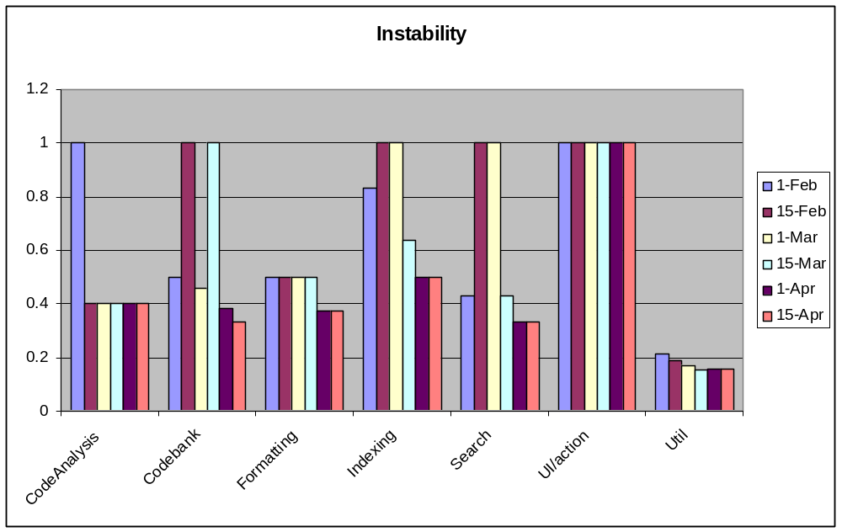

Using Martin’s formula, Metrics 1.3.5 calculates Instability = Ce / (Ca + Ce). Afferent coupling (Ca) is the number of classes outside a package that depend on classes inside the package, and efferent coupling (Ce) is the number of classes inside a package that depend on classes outside the package.

A value of zero describes a completely stable package, while a value of one indicates a completely instable package. This metric helps show each package’s resilience to change.

Lack of Cohesion of Methods

 | February 1 | February 15 | March 1 | March 15 | April 1 | April 15
CodeAnalysis | .167 | .2 | .2 | .214 | .214 | .214
Codebank | .276 | .347 | .276 | .276 | .276 | .303
Formatting | .889 | .889 | .889 | .889 | .25 | .25
Indexing | .183 | .12 | .301 | .256 | .198 | 0
Search | .333 | .333 | .333 | .333 | .292 | .3
UI/action | 0 | 0 | 0 | 0 | 0 | 0
Util | 0 | 0 | 0 | 0 | 0 | 0

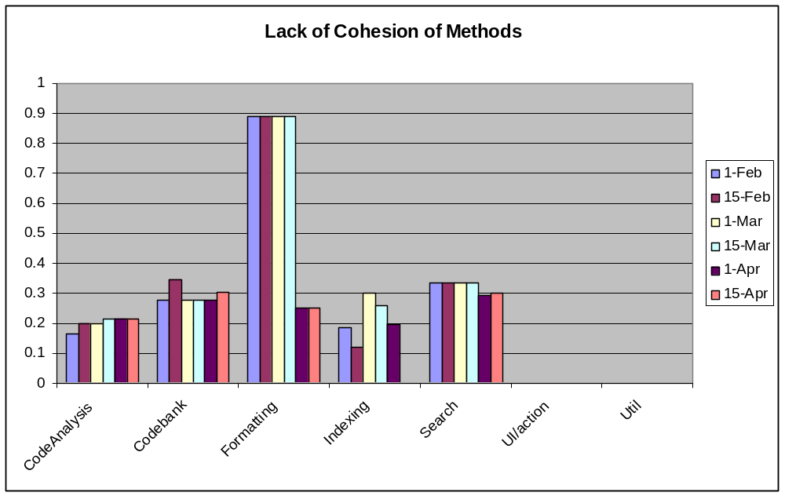

Lack of cohesion measures how much a class in a package supports a singular purpose within the system.

This metric helped us determine the degree in which the methods within the classes work together for a well-bounded design of the classes. Any lack of cohesion will be a flag for identifying flaws for us to refactor to decrease the complexity and increase reusability. After examining the classes in the Formatting package we identified several reasons for the lack of cohesiveness in their implementation. We realized that the code was split into Java and native C/C++ code which prevented the metrics from being collected correctly. However, we were able to refactor the classes in such a way as to increase cohesiveness even with that separation.

Abstractness

 | February 1 | February 15 | March 1 | March 15 | April 1 | April 15
CodeAnalysis | 0 | 0 | 0 | 0 | 0 | 0
Codebank | .273 | .083 | .111 | .111 | .111 | .3
Formatting | 0 | 0 | 0 | 0 | 0 | 0
Indexing | 0 | 0 | 0 | 0 | 0 | 0
Search | 0 | 0 | 0 | 0 | 0 | 0
UI/action | .143 | .143 | .167 | .167 | .125 | .125
Util | 0 | 0 | .333 | .333 | .333 | .333

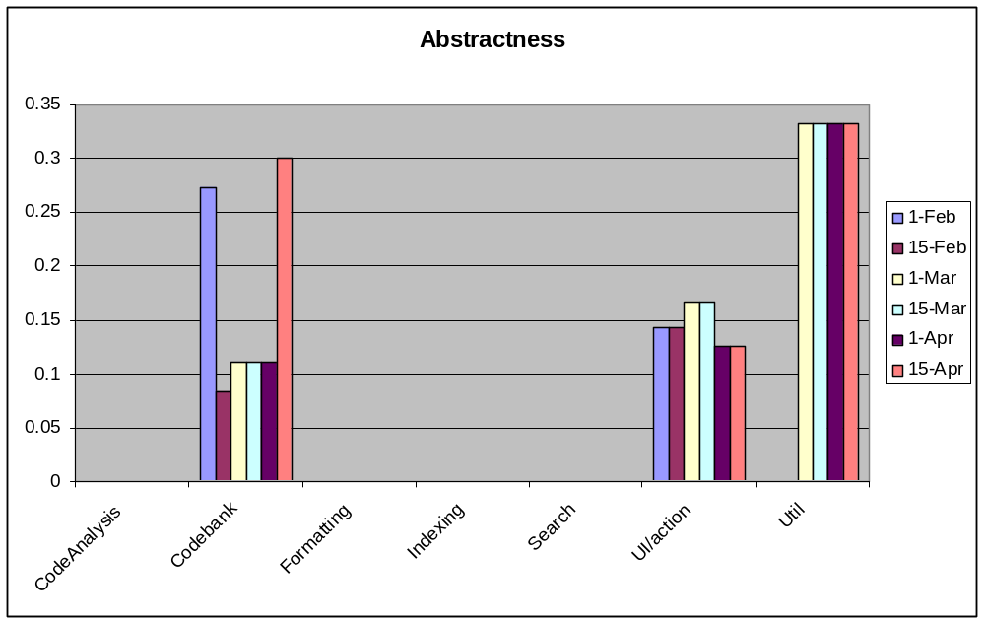

Abstractness is the ratio of abstract classes in a package and the total number of classes in that package. This metric was used in conjunction with the Instability metric to isolate reusable elements.

Weighted Methods per Class

 | February 1 | February 15 | March 1 | March 15 | April 1 | April 15
CodeAnalysis | 13 | 13 | 13 | 18 | 25 | 25
Codebank | 81 | 119 | 109 | 109 | 110 | 128
Formatting | 14 | 14 | 14 | 14 | 43 | 43
Indexing | 46 | 46 | 68 | 47 | 59 | 94
Search | 11 | 11 | 11 | 11 | 15 | 19
UI/action | 31 | 31 | 31 | 31 | 32 | 37
Util | 45 | 45 | 47 | 126 | 155 | 159

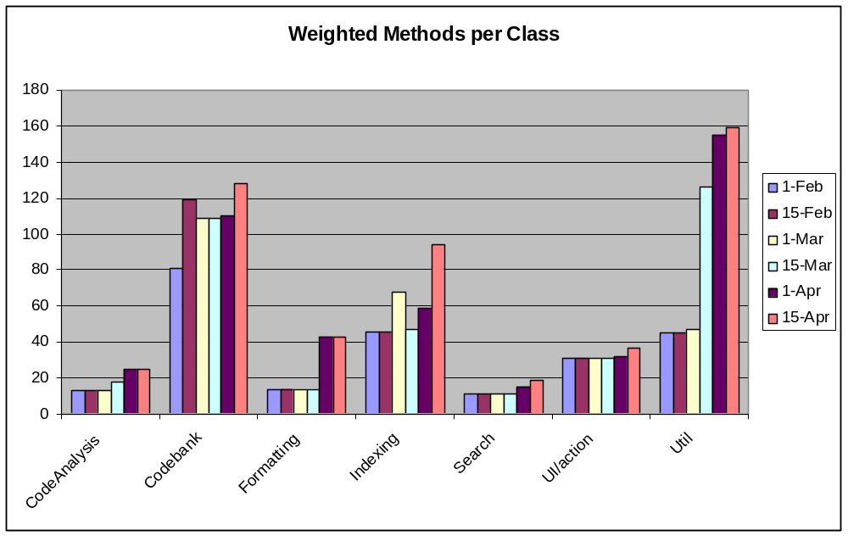

The Weighted Methods per Class is the sum of the number of the McCabe Cyclomatic Complexity for all methods of a class. (The McCabe counts the number of flows through a method.) WMC is a predictor of the level of time and effort to develop and maintain the class design. This metric is most useful for measuring understandability, maintainability and re-usability. Most packages have a low complexity level. However, the classes in the Util package may need to be revisited and refactored.

Dependency Graphs

Util Package

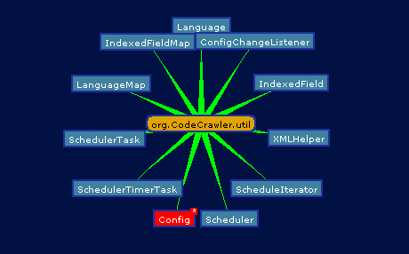

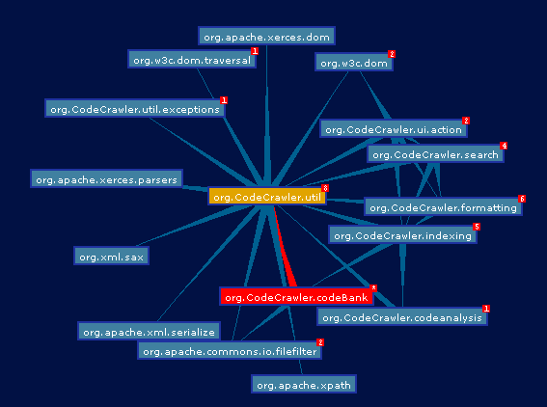

CodeBank CVS Portion

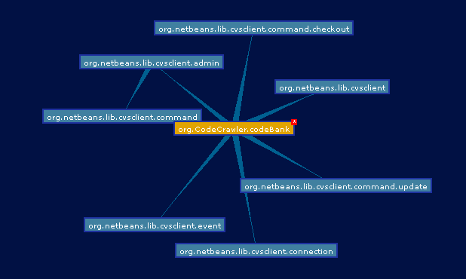

CodeBank without CVS
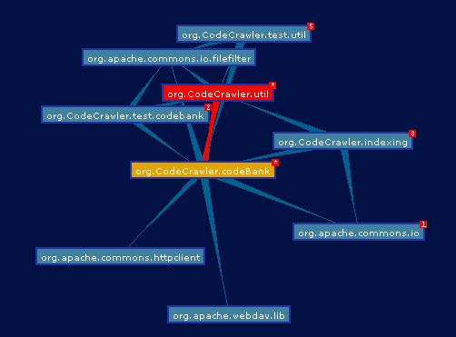

CodeCrawler Indexing

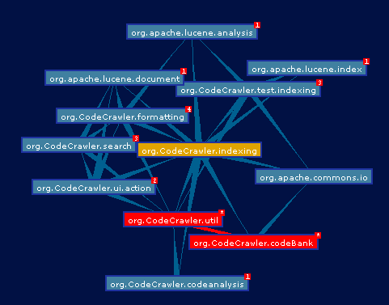

Formatting

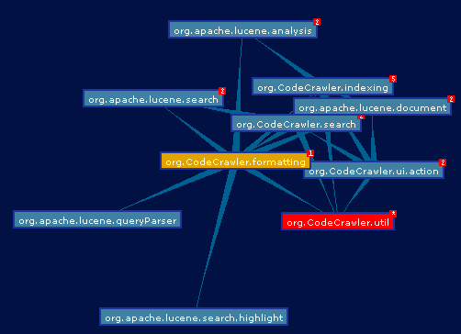

Search

